# Parametric Value at Risk (VaR)

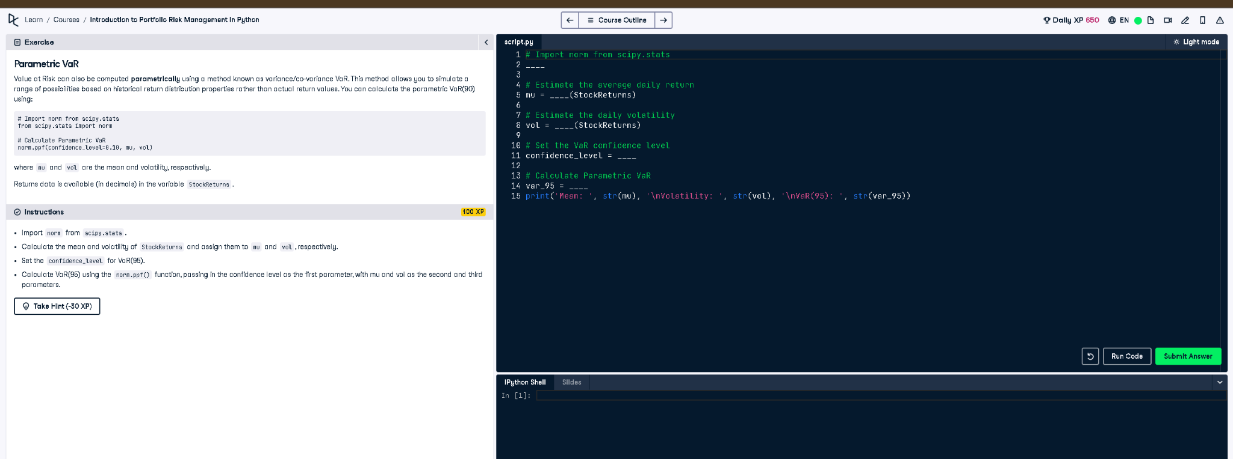

## Python Code

# Import norm from scipy.stats  
from scipy.stats import norm  
  
# Estimate the average daily return  
mu = np.mean(StockReturns)  
  
# Estimate the daily volatility  
vol = np.std(StockReturns)  
  
# Set the VaR confidence level  
confidence_level = 0.05  
  
# Calculate Parametric VaR  
var_95 = norm.ppf(confidence_level, mu, vol)  
print('Mean: ', mu, '\nVolatility: ', vol, '\nVaR(95): ', var_95)

## Explanation (Simple Words)

This code calculates the 95% parametric Value at Risk (VaR). It assumes returns are normally distributed. The average return (mu) and volatility (vol) are calculated from past data. Using the norm.ppf() function, the VaR at the 5% left tail is estimated, representing the maximum expected loss with 95% confidence.